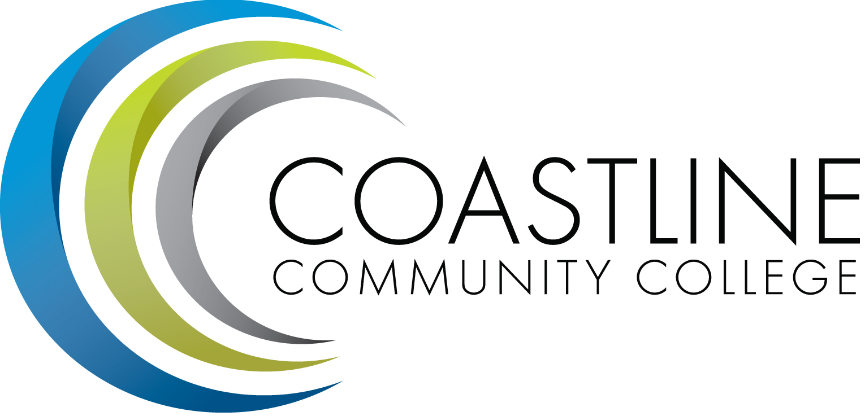
Planning, Institutional Effectiveness, and Accreditation Committee (PIEAC)
October 5, 2016
1:30 p.m. to 3:30 p.m.
Fourth Floor Conference Room

- CALL TO ORDER
  - Roll Call
  - Welcome
  - Adoption of Agenda
  - Approval of Minutes: September 21, 2016

- DISCUSSION & ACTION ITEMS
2.1 Committee Mandate V. Rodriguez
2.2 Report on 50% law C. Nguyen
2.3 Key Performance Indicators A. Zentner

3. STANDING REPORTS
3.1 Accreditation V. Rodriguez
3.2 Budget Committee R. Lockwood
3.3 Program Review A. Zentner
3.4 Grants D. Aistrich
3.5 President’s Report L. Adrian
3.6 Wing Reports V. Rodriguez, C. Nguyen, R. Miyashiro
3.7 College Council V. Rodriguez
3.8 Facilities C. Nguyen
3.9 Contract Education J. Groot
3.10 Student Success Committee D. Pittaway
3.11 Institutional Effectiveness Grant A. Zentner
3.12 Other Committees Committee

4. ANNOUNCEMENTS (1-2 minutes per)

5. ADJOURNMENT

